1.SELECT
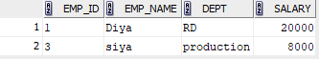

6.
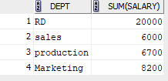
7. Update the salary of employees in the 'Production' department by adding 5% to their current salaries.
1 rows updated.
8. .Delete all employees with salaries below 7000.
1 rows deleted.
9. Find the employee with the lowest salary and display their name and salary.
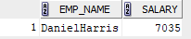
10. Update the salary of employees in the 'Marketing' department to 8200.00.
1 rows updated.
11. Find the names of all employees starting with the alphabet 'A':
12. List the names of all employees whose empname contains the substring 'it':
1 rows inserted.
13. List all departments in Upper Case Format

